Rittal and EcoG at “The Smarter E Europe” 2024
Industry standards for faster charging infrastructures
Herborn, 2024-06-20.
Electromobility is advancing worldwide, and the number of electric vehicles is set to increase rapidly. Similarly, the charging infrastructure will have to grow at the same rate to keep the electricity flowing and, with it, the traffic. At “The Smarter E Europe” in Munich, Rittal and technology company EcoG use the “Powerblock Starter Kit” to demonstrate how coordinated hardware and software as electrifying standards ensure faster expansion and reliability at the charging station.
It will take a lot of speed to expand the charging stations and charging parks so that electromobility and its contribution to the energy transition can keep on growing. Rittal, together with the technology company EcoG, is showing how this can be done: A “Powerblock” based on the bayable CS Toptec outdoor enclosure will be presented at the trade fair booth, combining Rittal’s system expertise in the fields of enclosures, power distribution and climate control with EcoG’s software expertise. The “Powerblock” at the trade fair booth thus embodies the common interest in standardising infrastructure solutions for charging parks and significantly accelerating the expansion of the charging infrastructures by scaling them up with pre-designed solutions in the form of “Industry Standard Projects”.
A second “Powerblock” can be seen at the EcoG exhibition stand (Power2Drive exhibition area, Hall C6, Booth 130). The software and other technological expertise of the Munich-based start-up, founded in 2017, brings a high degree of reliability to the often still vulnerable charging infrastructure and is now installed in 15 per cent of European fast-charging stations. Therefore, the software is called “The Windows for charging stations”, according to Germany’s Handelsblatt newspaper. Combined with Rittal’s standardised hardware components, this establishes an intelligent charging infrastructure that will help the rapid triumph of electromobility and the energy transition.
“We need a high level of standardisation and interacting software and system technology to speed up the urgent expansion of charging infrastructure,” explains Raphael Görner, Head of the Global Energy & Power Solutions business unit at Rittal: “EcoG has a great chance to become the standard software for charging infrastructure. It’s a promising match to Rittal’s system approach in pursuing this common goal.” EcoG’s CEO Joerg Heuer added: “Rittal brings many years of system expertise in enclosures, power and climate control. Together with our software approach and system experience, we create “Powerblocks” that improve the infrastructure’s reliability.”

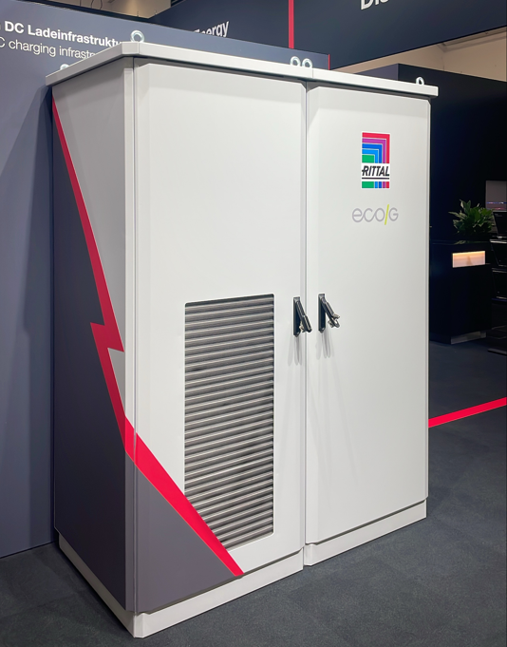 |  | 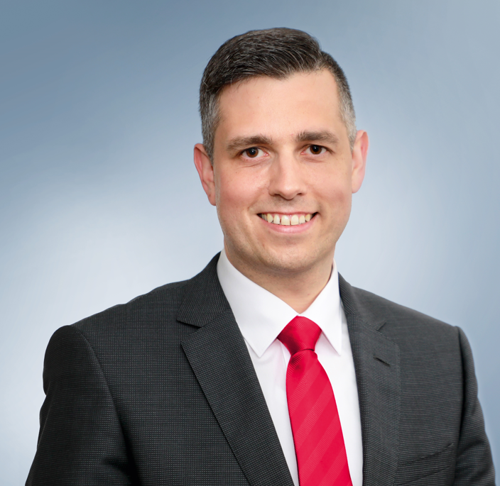
Image 1  A “Powerblock” based on the bayable CS Toptec outdoor enclosure will be presented at the trade fair booth, combining Rittal’s system expertise in the fields of enclosures, power distribution and climate control with EcoG’s software expertise. |  | Image 2  Raphael Görner, Head of the Global Energy & Power Solutions business unit at Rittal: “We need a high level of standardisation and interacting software and system technology to speed up the urgent expansion of charging infrastructure.”
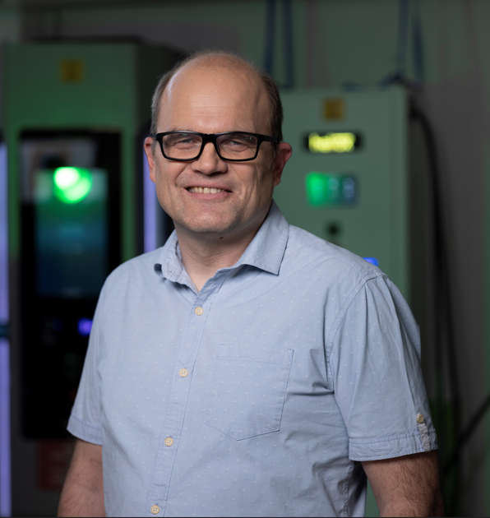

Image 3
Jörg Heuer, CEO EcoG: “Rittal brings many years of system expertise in enclosures, power and climate control. Together with our software approach and system experience, we create “Powerblocks” that improve the infrastructure’s reliability.”

May be reproduced free of charge. Please name Rittal GmbH & Co. KG as the source.

Rittal

Rittal is a leading global supplier of enclosure systems, automation and infrastructure with its industrial, IT, energy and power, cooling and service units. Rittal products and solutions are used in over 90% of global industries – standardised, customised, and always of the very best quality.
Our approach and methodology: Rittal, Rittal Software Systems (Eplan, Cideon and German Edge Cloud) and Rittal Automation Systems (RAS, Ehrt, Alfra) combine their hardware and software expertise to streamline, optimise and digitalise processes across the entire value chain for our customers including their IT infrastructure – from control and switchgear construction, machine building to factory operators or the energy sector.
Our delivery promise: Rittal standard products are delivered in Germany within 24 hours, and within 48 hours throughout Europe.
Customer focus
Improving efficiency and increasing productivity through automation and digitalisation is one of the biggest challenges for our customers. This requires in-depth knowledge and expertise, the combination of hardware and software, and cross-sector networking. We are convinced that creating and connecting data rooms is crucial to the success of industrial transformation. And that is exactly our speciality and field of competence.
Eplan and Rittal are driving the development of the digital automation twin, making data accessible and useable in operations as well. Cideon is improving data consistency in the digital product twin context with its CAD/CAM, PDM/PLM and product configuration expertise. German Edge Cloud’s ONCITE Digital Production System (DPS) makes production process data transparent, enabling it to be optimised – right through to energy management using digital production twins.
Sustainability
Environmental and climate protection, social commitment and ethical corporate management are a given for Rittal. We take our responsibility for a sustainable future seriously. Our approach to resource management and conservation involves continuous improvement of our own production processes and ensuring that our products have the lowest possible Product Carbon Footprint. Our solutions support our customers in achieving their own climate targets.
Family business and global player
Founded in 1961, Rittal is the largest company in the owner-operated Friedhelm Loh Group. The group operates worldwide, with 12 production sites and 95 international subsidiaries. It has 12,100 employees and posted revenues of 3 billion euros in fiscal 2023. In 2023, the Friedhelm Loh Group was presented with the “Best Place to Learn” and “Employer of the Future” awards. In 2024, Rittal was awarded the Top 100 Seal as one of Germany’s most innovative medium-sized companies for the third time in a row.
For more information, visit www.rittal.com and www.friedhelm-loh-group.com.

Corporate Communications
Dr. Carola Hilbrand Rittal GmbH & Co. KG
Corporate & Brand Communications Auf dem Stützelberg
Tel.: 02772/505-2527 35745 Herborn
hilbrand.c@rittal.de www.rittal.com


Follow us:

